**CNN Model for Image Classification of Skin Lesions**

**(Melanoma, Nevus, Seborrheic-Keratosis)**

**Members:**

Harsh Aggarwal (2020508)

Harsh Krishan (2020509)

We created a CNN model to successfully classify the cancerous skin lesions (Melanoma, Nevus, Seborrheic-Keratosis), this report is about the final results and whole process how we implemented it.

First we want to discuss the results of our model:

* We created total 11 models to do the task.
* The best accuracy we got through the best of our models was **65.5%**
* We have also checked the accuracy of pre-trained models like VGG-16 and mobileNet, they got almost **79%** and **80%** respectively.

The confusion matrix of the best of our models is shown below.

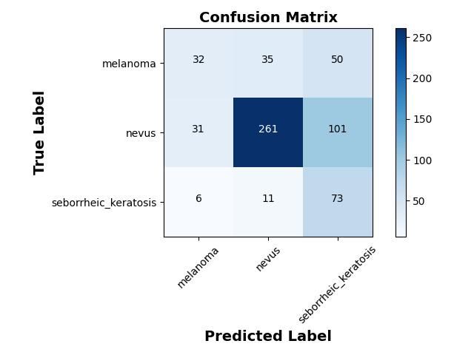

The following materials are present in the final zip file:

* The model (HDF5 format)
* The prediction file (with 65.5% accuracy)
* The confusion matrix plot
* The main python notebook

**Procedure:**

* **Importing Required Python Liabraries:**
  + We used the following python libraries for the project:
    - **Numpy:** For basic mathematical operations on dataframe
    - **Keras:** For building the CNN model
    - **Pandas:** For managing the dataframe
    - **Scikit-Learn:** For Image Processing and Metrics Evaluation
    - **Matplotlib:** For plotting the plots
    - **OS:** For managing the directory
* **Data Preparation:**
  + We did the following for data preparation part:
    - Data path setup
    - Data files loading
    - Image data preprocessing, by converting image from RGB to BGR format using ImageDataGenerator module from “keras.preprocessing.image”
    - Changing the dimensions of image to 224 x 224
    - Splitting the data into batches to make them suitable for k-cross fold validation, done later
* **Class Imabalance:**
  + There was a drastic class imbalance in the data, so we did data augmentation in each step of k-cross validation to reduce the bias of one class over other classes
* **Defining the CNN Model:**
  + The following is the description of our sequential CNN model layer by layer:

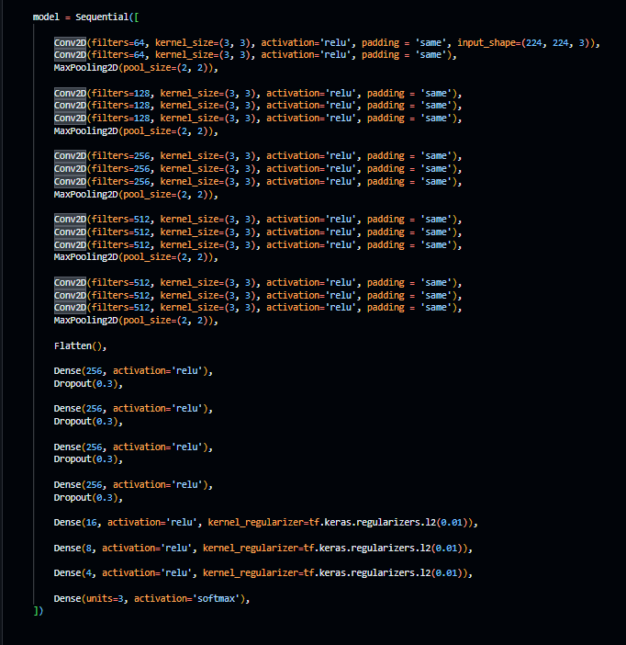

* **Model Compilation:**
  + We use Adam as optimizer and we used accuracy as the metrics for our model
* **Model fitting:**
  + We did 10 cross validation, in each iteration we did the following operations:
    - We took 9 batches for training and remaining 1 batch and given validation dataset combined for validation
    - We did data augmentation to handle class imbalance
    - We then calculated test score for each step
    - After all above operations we deleted all generated augmented images, so they cannot be repeated again in another iteration
* **Saving Model:**
  + Since the model took almost 10 hours for each iteration, so it would be impractical to train model again, that’s why we saved the model. Model file name “model_11.h5”
* **Predicting results:**
  + We predicted the results, and got 65.5% accuracy, prediction file “predictions_11.csv”.